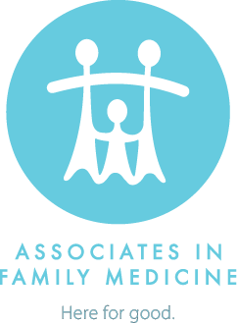
WEARING A MASK AT AFM
Updated: August 27, 2021
To protect our patients, staff, and community from the spread of the 2019 novel coronavirus that causes COVID-19, AFM requires that all patients and visitors over the age of 2 wear a solid-barrier mask or face covering that covers the nose and mouth and fits securely under the chin. You must keep your mask or face covering on during the entire visit, even when you are alone in a room.
AFM will no longer allow the following face coverings in our offices, as they are not highly effective in limiting or preventing the transmission of respiratory droplets:
- Bandanas
- Neck gaiters
- Vented masks
- Any mask made out of open-weave or fleece material
For more information, visit the CDC’s guidelines on how to select, wear, and clean your mask.

